7.19: The initial kinetic energy and the kinetic energy of the brick at its greatest height are both zero. Equating initial and final potential energies, 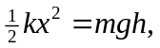 where is the greatest height. Solving for h,
